***Student name and ID:***

Tram Anh Vu

***Course and Title:***

CSIS3380 – Advanced Web Programming – Javascript/AJAX

**Part 1: Creating a MongoDB Database**

1. **Topic selection**

We shall implement a database that stores a list of books for a fictious library, Smart Readers Library.

1. **Data Model**

|  |  |  |
| --- | --- | --- |
| **Attribute** | **Datatype** | **Constraint** |
| ISBN | String | Required |
| Title | String | Required |
| Author | String | Required |
| Copies | Integer | Required |

1. **Mongo database Creation**

Database Name: MyLibraryDB

Collection Name: items

1. **Inserting Documents**

[

{"ISBN":"345994784","Title":"Web design","Author":"Hanny Leeds","Copies":"56"},

{"ISBN":"356994785","Title":"Introduction to Computer Science","Author":"Peter James","Copies":"34"},

{"ISBN":"367994786","Title":"Software Engineering","Author":"Chen Drays","Copies":"45"},

{"ISBN":"378994787","Title":"Artificial Intelligence","Author":"Daniel James","Copies":"90"},

{"ISBN":"389994788","Title":"Linear Algebra","Author":"Cate Ivy","Copies":"65"},

{"ISBN":"400994789","Title":"Software Engineering","Author":"Mary Doe","Copies":"45"},

{"ISBN":"411994790","Title":"Database Management Systems","Author":"Alex Smith","Copies":"120"},

{"ISBN":"422994791","Title":"Computer Graphics","Author":"David Roy","Copies":"89"},

{"ISBN":"433994792","Title":"Mastering Accounting","Author":"\tMaurice Ben","Copies":"42"},

{"ISBN":"444994793","Title":"Advancing in Linear Algebra","Author":"David Cool","Copies":"50"},

{"ISBN":"455994794","Title":"Introduction to Microbiology","Author":"Ken Pool","Copies":"30"},

{"ISBN":"466994795","Title":"Body Fitness","Author":"Griffins Tales","Copies":"12"},

{"ISBN":"477994796","Title":"Romeo and Juliet","Author":"Jullie Smart","Copies":"32"},

{"ISBN":"488994797","Title":"Data Analytics","Author":"Mitchel Blues","Copies":"56"},

{"ISBN":"499994798","Title":"MySQL Database","Author":"John Paul","Copies":"34"},

{"ISBN":"510994799","Title":"Web design","Author":"Hanny Leeds","Copies":"45"},

{"ISBN":"521994800","Title":"Introduction to Computer Science","Author":"Joylin Kitts","Copies":"90"},

{"ISBN":"532994801","Title":"Software Engineering","Author":"Henry Reign","Copies":"65"},

{"ISBN":"543994802","Title":"Mastering football skills","Author":"Mathews Newton","Copies":"45"},

{"ISBN":"554994803","Title":"Tour to Jupiter","Author":"Justin Stars","Copies":"120"},

{"ISBN":"565994804","Title":"In love with Ramon","Author":"Audrey Smart","Copies":"89"},

{"ISBN":"576994805","Title":"Mastering Healthy Nuitrition","Author":"Merab Claws","Copies":"20"},

{"ISBN":"587994806","Title":"Graphics Design","Author":"Dion Chains","Copies":"51"},

{"ISBN":"598994807","Title":"Lions and his family","Author":"Mary Leads","Copies":"80"},

{"ISBN":"609994808","Title":"Advanced Poetry","Author":"Fred Chains","Copies":"72"},

{"ISBN":"620994809","Title":"History of the world","Author":"Ever Clarks","Copies":"50"},

{"ISBN":"631994810","Title":"Java 8 Programming","Author":"Peter James","Copies":"60"},

{"ISBN":"642994811","Title":"Database Systems","Author":"Chen Drays","Copies":"140"},

{"ISBN":"653994812","Title":"World Amazing Geographical Features","Author":"Daniel James","Copies":"22"},

{"ISBN":"664994813","Title":"Mastering History of the World","Author":"Cate Ivy","Copies":"78"},

{"ISBN":"675994814","Title":"Advanced Poetry","Author":"Mary Doe","Copies":"56"},

{"ISBN":"686994815","Title":"Advanced Literature","Author":"Alex Smith","Copies":"34"},

{"ISBN":"697994816","Title":"Mastering Software Engineering","Author":"David Roy","Copies":"56"},

{"ISBN":"708994817","Title":"Advanced Artificial Intelligence","Author":"\tLeah Kyogs","Copies":"30"},

{"ISBN":"719994818","Title":"Business Information Systems","Author":"Richard Sails","Copies":"12"},

{"ISBN":"730994819","Title":"Linear Algebra","Author":"Kelly Grams","Copies":"34"},

{"ISBN":"741994820","Title":"Mathematical Logic","Author":"Jackson Miles","Copies":"22"},

{"ISBN":"752994821","Title":"Database Management Systems","Author":"Faith Hillary","Copies":"34"},

{"ISBN":"763994822","Title":"Project Management","Author":"Harcules James","Copies":"50"},

{"ISBN":"774994823","Title":"Algorithms","Author":"Paul Charles","Copies":"23"},

{"ISBN":"785994824","Title":"Procedural Programming","Author":"Zacharia Essy","Copies":"66"},

{"ISBN":"796994825","Title":"Database Management Systems","Author":"Dennis Miles","Copies":"45"},

{"ISBN":"807994826","Title":"Advanced Data Science","Author":"Davido Titus","Copies":"100"},

{"ISBN":"818994827","Title":"Advanced electonics","Author":"Wilson Maya","Copies":"45"},

{"ISBN":"829994828","Title":"Surgery Essentials","Author":"Lydia Tarius","Copies":"53"},

{"ISBN":"840994829","Title":"Managerial Accounts","Author":"Roberts Sailing","Copies":"77"},

{"ISBN":"851994830","Title":"Introduction to Statistics","Author":"Harry Paul","Copies":"66"},

{"ISBN":"862994831","Title":"Computer Graphics","Author":"Greeks Zion","Copies":"44"},

{"ISBN":"873994832","Title":"Software Engineeeing","Author":"Isaac Chen","Copies":"56"},

{"ISBN":"884994833","Title":"Programming with Java","Author":"Alex Jay","Copies":"34"}

]

**Part 2: Configuring Backend Server, Data Model, and Routes**

1. 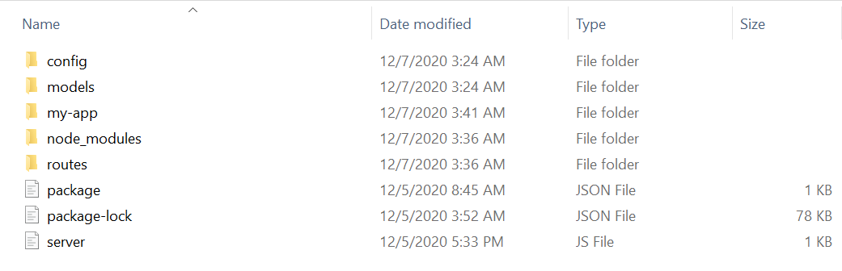Project Structure
2. **Mongoose Data Model**

const mongoose = require("mongoose");

const Schema = mongoose.Schema;

// Create Item Schema

const ItemSchema = new Schema({

ISBN: {

type: String,

required: true

},

Title: {

type: String,

required: true

},

Author: {

type: String,

required: true

},

Copies: {

type: Number,

required: true

},

});

// Export the Schema

module.exports = Item = mongoose.model("item", ItemSchema);

1. **Routes file**

const express = require('express');

const router = express.Router();

//Products Model

const Item = (require('../../models/Item'));

//@route GET api/items

//@desc GET All items

//@access Public

router.get('/',(req, res)=>{

Item.find()

.then(items=>res.json(items));

});

//@route POST api/items

//@desc Add new Item

//@access Public

router.post('/',(req, res)=>{

const newItem = new Item({

ISBN:req.body.ISBN,

Title:req.body.Title,

Author:req.body.Author,

Copies:req.body.Copies,

})

newItem.save().then(item=>res.json(item));

});

//@route DELETE api/items?:id

//@ Delete an item

//@access Public

router.delete('/:_id',(req, res)=>{

Item.findById(req.params._id)

.then(item=>item.remove().then(()=>res.json({success:true})))

.catch(err=>res.status(404).json({success:false}));

});

module.exports = router;

1. **Database configuration file**
2. module.exports = {
3. mongoURI: 'mongodb://localhost/MyLibraryDB'
4. }
5. **Sever file**
6. const express = require('express');
7. const mongoose = require('mongoose');
8. const bodyParser = require('body-parser');
9. const items = require('./routes/api/items');
10. const app = express();
11. //Bodyparser Middleware
12. app.use(bodyParser.json());
13. // Configure Mongo
14. const db = require('./config/keys').mongoURI;
15. // Connect to Mongo with Mongoose
16. mongoose
17. .connect(
18. db,
19. { useNewUrlParser: true }
20. )
21. .then(() => console.log("Mongo connected"))
22. .catch(err => console.log(err));
23. //use routes
24. app.use('/api/items', items);
25. // Specify the Port where the backend server can be accessed and start listening on that port
26. const port = process.env.PORT || 5000;
27. app.listen(port, () => console.log(`Server up and running on port ${port}.`));
28. **Get Router**

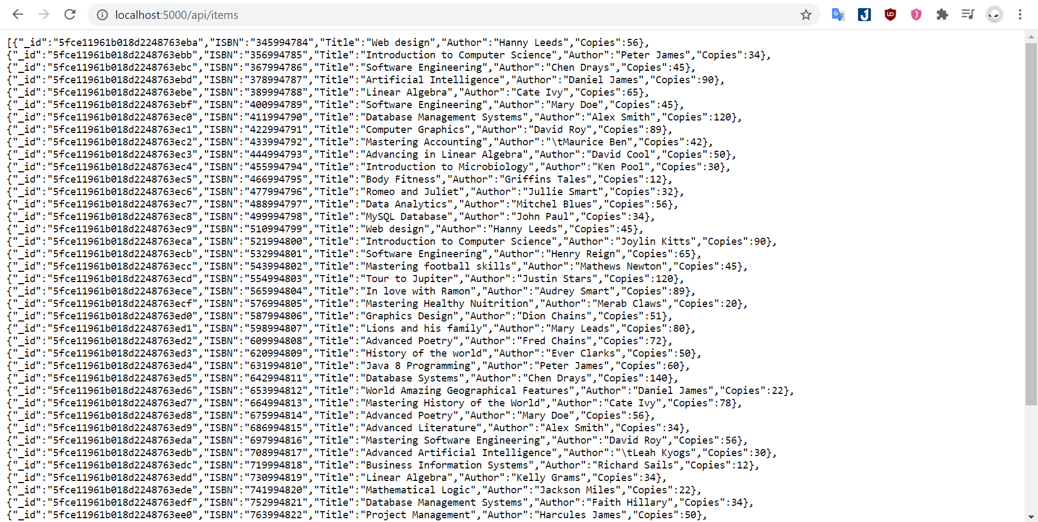

**Part 3: Developing the Frontend (React App)**

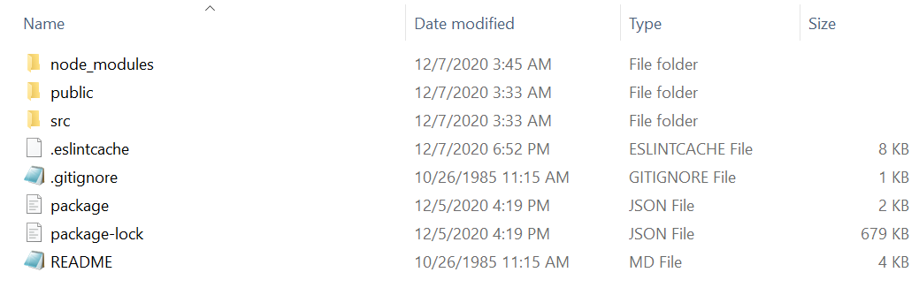**File Structure**

**User Interface for Inserting Books**

